

Socio-Economic Characteristics of Visible Minorities in Ottawa
FACT SHEET No. 2, 2007

Introduction

One of the recurring themes in literature about diversity in Canada is the disparities between the socio-economic outcomes of the mainstream and visible minority society. Literature shows that despites being relatively well educated, visible minorities and immigrants are more likely to experience difficulties in accessing good jobs and consequently, fall into the low income segment of the population (Galabuzi, 2001). Literature further suggests that this phenomenon is not new and will persist if no deliberate efforts are made to stop it. This summary/fact sheet reaffirms what Galabuzi and others has argued by showing that visible minority groups in Ottawa are more likely to experience unemployment and low income than mainstream groups. It also suggests that while visible minorities may find it easier to create their social spaces and organizations within the city of Ottawa, it is extremely difficult for them to access the economic structure, especially when it comes to top jobs. This summary explores the educational attainment, labor market outcomes and income levels of visible minorities in Ottawa.

Language skills and Educational attainment

Table 1: Ottawa Residents by Knowledge of Official Languages, 2001
Language(s) | Visible Minority | Non Visible Minority
English Only | 68.1 | 57.4
French Only | 2.6 | 1.6
English & French | 23.1 | 40.7
Neither English nor French | 6.1 | 0.3
Total | 100.0 | 100.0
It is important for visible minorities to have good knowledge of at least of the two official languages in order to enhance their ability to get good jobs. In Ottawa, the demand for ‘bilingual’ language skills is more pronounced because of the importance of the federal government as an employer. The federal government strictly adheres to bilingual requirements for most of the senior positions.
Source: Statistics Canada, Census 2001.

Data from the 2001 Census shows that percentage of bilingual non visible minorities is almost double the percentage of bilingual visible minorities. If we consider the actual numbers the differences may be even much bigger. Furthermore, there is a higher percentage of visible minorities who not bilingual. The data shows that visible minorities in Ottawa are at a disadvantage when it comes to language skills, especially bilingualism. Furthermore, qualitative data collected by the Social Planning Council (2006) shows that visible minorities do not only have to master the official but also have good Canadian communications. This is difficult for visible minorities whose mother language and culture are not Canadian.

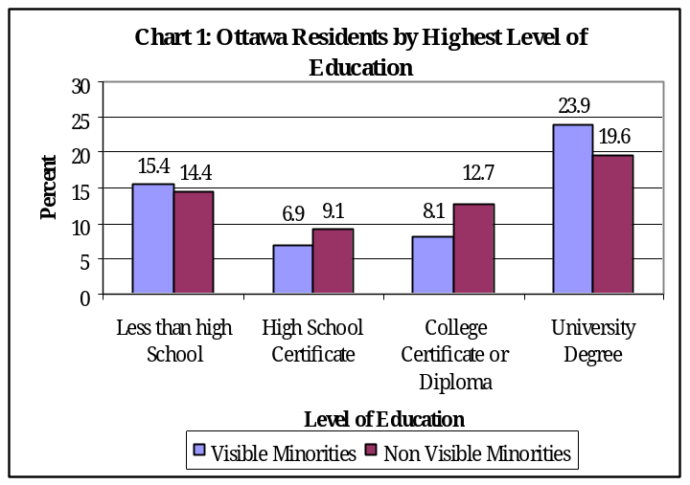
The data from the Census 2001 shows that visible minorities are more likely to have attained a university than non visible minorities. It shows that the proportion of visible minorities who had attained a university degree was higher than that of non visible minorities. However, the Census statistics also indicate that non visible minorities are more likely to have attained a college diploma or certificate than visible minorities. These mixed results may imply that neither of the two groups that were studied enjoyed a marked advantage when entering the labor market. However, if we considered the actual numbers of university graduates we would find that there are more university degree holders among non visible minorities than amongst visible minorities. Therefore, visible minorities may face an even bigger challenge when they seek skilled jobs.

Table 2: Ottawa Residents by Fields of Specialization, 2001
Perhaps a look at the predominant fields of specializations among Ottawa’s residents could provide a clearly position about their educational qualifications. Management, professional and technical specializations are generally regarded as being very marketable and highly remunerating. The data from the Census 2001 shows that the most popular field of specialization was Commerce, Management and Business Administration for both visible minorities and non visible minorities. However, the percentage of non visible minorities in this field of specialization is slightly higher than of visible minorities. Visible minorities also tend to prefer Engineering and Mathematics while non visible minorities tend be concentrated in Applied Sciences.
Visible Minorities |  | Non Visible Minorities
Specialization | Percent | Specialization | Percent
1 Commerce, Management and Business Administration | 18.0 | 1 Commerce, Management and Business Administration | 20.4
2. Engineering and Applied Sciences | 16.8 | 2. Applied Science Technologies and Trades | 15.6
3. Mathematics, Computers and Physical Sciences | 12.5 | 3. Social Sciences and Related Fields | 15.4
4. Social Sciences and Related Fields | 11.6 | Health Professions and related technologies | 9.5
Source: Statistics Canada, Census 2001.

The other field specialization that is common to both non visible minorities and visible minorities was Social Sciences. Generally speaking, the differences in field of specializations are not so significant as to warrant major differences in the labor market outcomes of the two groups.

Labor Market Outcomes

The Labor force participation rate shows that proportion of working age (15-64 years) individuals who are working or are available for work. It is a measure of the supply of labor in a given population. Information from the Census 2001 shows that the labor force participation rate for non visible minorities in Ottawa was slightly higher than that of the visible minorities. In other words, there was no significant difference in the availability for work among non visible minorities and visible minorities. (See Chart 2)

The employment rate depicts the proportion of the working age population that is actually in employment on full or part time basis. It includes all persons who were either employees or self-employed. The difference between the employment rate and the Labor force participation rate is that the former

does not include those who may want to work but cannot find a job in its numerator while the latter does. The data from the 2001 Census shows that the employment rate for the non visible minorities was 7 percentage points higher than that of the visible minorities. This is an indication that visible minorities may have more difficulty in accessing jobs than non visible minorities.

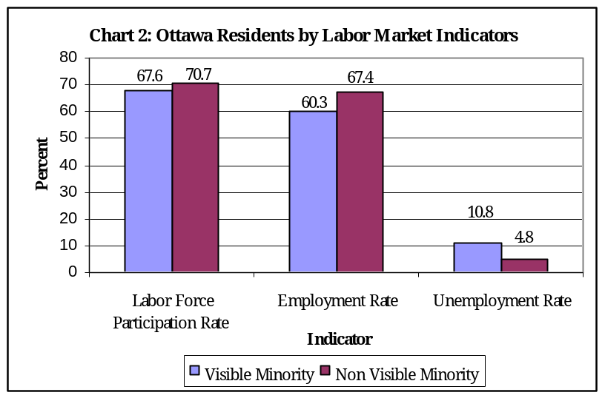
The unemployment rate is the proportion of individuals in labor force who are actively looking for work but cannot find it due to reasons beyond their control. The unemployment rate excludes all individuals who are not available for work even if they are within the working age. According to the statistical information from the Census 2001, the unemployment rate for visible minorities in Ottawa is more than that of the non visible minorities. This is a remarkable outcome given the fact that the other labor market indicators considered above do not show huge disparities. This outcome indicates that visible minorities have more difficulties in accessing the labor market than non visible minorities in Ottawa.

Qualitative information collected from the Chinese, Lebanese and Somali communities in Ottawa shows that one of the reasons for the relatively higher unemployment rate among visible minorities in Ottawa is the lack of recognition of foreign qualification and experience. Most visible minorities, who are recent immigrants, usually find themselves unable to compete for jobs in their fields of specialization because of their qualifications are not recognized. Furthermore, the process of certification in regulated career professions such medicine and law is very complicated leading to the exclusion of visible minorities from suitable jobs. Secondly, popular hiring practices such as recruiting from known social networks tend to deny visible minorities information about emerging opportunities. Some employers tend to averse towards foreign names, especially Arabic names which are associated with terrorism. Such employers tend be to overlook the resumes submitted by visible minorities. Lastly, within the work places it is difficult for visible minorities to gain promotion to higher position because of what was described as “ hidden discrimination” ; which is difficult to pinpoint and consequently, too intricate to redress.

The qualitative data collected by the Social planning Council (2006) also shows the exclusion of visible minorities from the economic sphere tends to impact negatively on their ability to participate in socio-cultural and civic activities. Visible minorities are unable to engage in many activities because of low levels of resources and high pressure of work. Most participants felt that if their labor market outcomes improved their possibilities of successful integration into Ottawa’s mainstreams will be greatly increased.

Income

The income available to a household has a bearing on its ability to afford an acceptable standard of living in which all the basic need s are met. Many households in Ottawa depend entirely of employment income to sustain themselves. Therefore, labor market outcomes have a direct impact of the incomes of families. Data from the Census 2001 shows that more than half of all visible minorities earned incomes that were below $20,000 per annum compared to one third of the non visible minority population. The percentages of non visible minorities who earned between $20,000 and $50,000; and $50,000 and above were much higher than those of visible minorities. This lopsided distribution of incomes between non visible

minorities and visible minorities is a partially a result of a higher unemployment rate among visible minorities. It could also imply that even those who employed amongst the visible minorities, the majority are more likely to be found in low paying industries and occupations. The qualitative study that was conducted by the Social Planning Council shows that visible minorities tend to be concentrated in specific industries and jobs, which are, in most cases, not highly remunerating. For instance, one in every

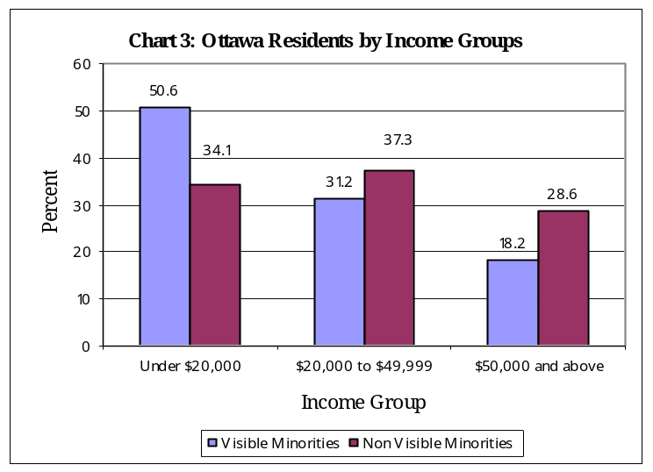
five Lebanese Canadians in Ottawa were working in the Accommodation and food services industry. Most of them were working in Sharwamas and other types of restaurants that are run by members of their ethnic group. Evidence from the qualitative study by the SPC suggests that most of the jobs in the food industry may not that remunerating. Almost a third of all Lebanese Canadian workers are involved in Sales and service occupations which are usually lowly paid (SPC, 2007). Therefore, we can conclude that visible minority jobs in Ottawa do not only face challenges in terms of finding jobs but even those who manage to get jobs are more likely to be in lowly paid occupations.

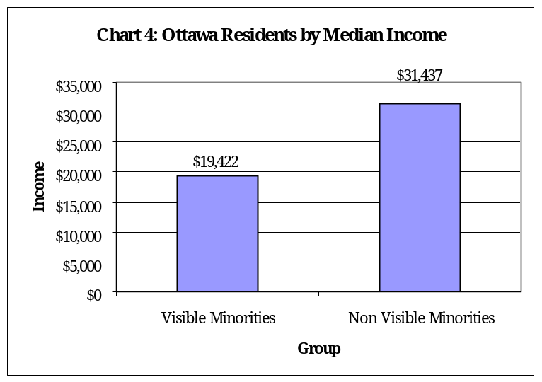
Another important measure of the disparities in income is the Median Income. The Median income divides individuals into two equal groups: the first group earned incomes that were below the median while the second group comprises of individuals whose incomes are below the Median or middle point. The pattern observed in the distribution of incomes is reaffirmed when we look the median income. The data shows that the median income for non visible minorities was more than $12,015 higher than the median income of the visible minorities. On average, the income of visible minorities in Ottawa is only 62 percent of the income of the non visible minorities. This disparity in the median income is not consistent with similarities in the educational attainments of non visible minorities and visible minorities in Ottawa. However, it is consistent with the earlier finding that visible minorities are more likely to be unemployed than non visible minorities in Ottawa.

The incidence of low income (See Chart 5) shows the proportion of households whose expenditure on basic food, shelter and clothing is at least 20 percent higher than the average Canadian family of the same size. It shows the percentage households who are unable to sustain an acceptable level of expenditure and consumption by Canadian standards. Statistical information from the Census 2001 shows that the incidence of low income among visible minorities is at least more than six times higher than that of non visible minorities. Notably, the disparities between visible minorities and non visible minorities tend to increase as we move from considering labor market indicators, to median income and finally, the

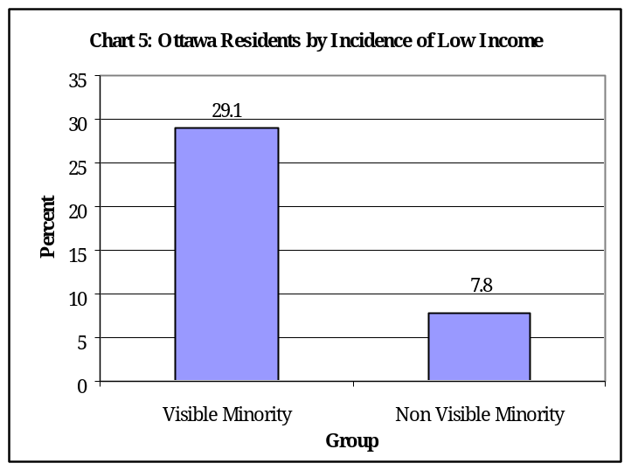
incidence of low. It is difficult to ascertain exactly the factors leading to this remarkable disparity in the incidence of low income. It could partly be because of poorer labor market outcomes and job segmentation into low paying jobs. This huge gap between the incidence of low among non visible minorities and visible minorities cannot be adequately dealt with without improving their labor market outcomes. A number of policy instruments such the Employment Equity Act have been formulated to improve access to the labor market among visible minorities. Nonetheless, the sharp differences in the incidence of low income still persist. There is a need for more efforts to narrow the gap between visible minorities and non visible minorities.

Conclusion

Ottawa’s visible minorities continue to lag behind non visible minorities when it comes to labor market outcomes and earnings. This is in spite of their comparable educational qualifications and professional experience. Ultimately, we observed that a bigger proportion of visible minorities in Ottawa live in low income households when compared to non visible minorities. As result of their lower socio-economic outcomes visible minorities find it difficult to take part in mainstream activities in a meaningful and sustained way. The end result is that the integration of visible of minorities into the mainstream society is stifled or delayed. There is need to improve the current policies that aimed at improving the socio-economic outcomes of visible minorities. If necessary, we need to consider other ways of helping visible minorities to improve their socio-economic outcomes. To begin with, the city of Ottawa needs to create strong and sustainable rapport with visible minority groups in order to ensure that policy formulation pertaining to the labor market outcomes is as inclusive as possible. Lastly, there is need to speed up the process of evaluating foreign credentials and obtaining certification in the regulated professions like medicine and law. One way in which this can be done is by increasing the number of centers for evaluating foreign credentials in Ontario and Ottawa. If possible it is better to encourage prospective immigrants to begin the process of evaluation of credentials or certification even before they make their way to Ottawa.

References

- Biles, John. 1998. Ottawa-Carleton: An EthniCity in the Making? Paper presented at the Third International Metropolis Conference. Zichron Yaacov, Israel.
- Galabuzi, Grace-Edward. 2001. Canada’s Creeping Economic Apartheid. Toronto. CSJ Foundation for Research and Education.
- Pendakur, Krishna and Ravi Pendakur. 2002. "Speaking in Tongues: Language Knowledge as Human Capital and Ethnicity" International Migration Review, Spring 2002, 36 (1), 147-178.
- Social Planning Council of Ottawa. 2006. Some Socio-Economic Characteristics of Visible Minority Groups in Ottawa. A PowerPoint Presentation to the Advisory Committee of the Ethnic Diversity and Social Exclusion Project.
- Social Planning Council of Ottawa. 2007. Lebanese Canadians in Ottawa. A PowerPoint Presentation to the Advisory Committee of the Ethnic Diversity and Social Exclusion Project.
- Statistics Canada. The definition of Visible Minority. http://www.statcan.ca/english/concepts/definitions/vis-minorit.htm
Accessed September 3, 2007.

Summary of Statistics

1. Percentage of “Bilingual” Visible Minorities in Ottawa = 23.1%
2. Percentage of University Degree holders among
Visible Minorities in Ottawa = 23.9%
3. Top four specializations among visible minorities in
Ottawa
Commerce, Management and Business Admin = 18.0%
Engineering and Applied Sciences = 16.8%
Mathematics, Computers & Physical Sciences = 12.5%
Social Sciences and related fields = 11.6%

4. Labor force participation Rate = 67.6%
5. Employment Rate = 60.3%
6. Unemployment Rate = 10.8%
7. Under $20,000 income group = 50.6%
8. $20,000-$49,999 income Group = 31.2%
9. $50,000 and above income group = 18.2%
10. Median Income = $19,422
11. Incidence of Low Income =29.1%

For further details contact:

Social Planning Council of Ottawa
280 Metcalfe Street, Suite 501
Ottawa ON K2P 1R7

Tel: 613 236-9300 ext 300
Fax: 613 236-7060
Email: office@spcottawa.on.ca
Website: www.spcottawa.on.ca




